GUI development rules

Styles and components

Use of Bootstrap styles and components: fonts, alerts and modals
Use of jQuery and Bootstrap plugins: datatables, columns visibility in datatables, blockUI and multiselect.

Files Structure and Common files:

Each web page (jsp, xhtml) has its own JavaScript file (*.js) that stores its specific functions - the purpose is to have the code organised by page.
global.js - global file that has all functions that are common to all pages
default.css - new styles should be added in this file

Inclusions
dependenciesInclusions.html - The inclusions which are used in all jsp files should be added to this file.
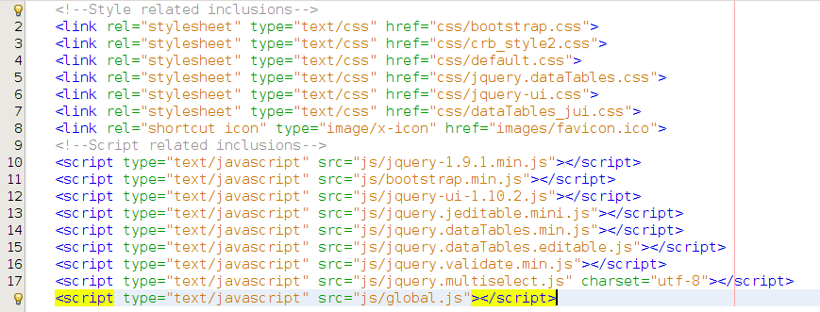
Don’t forget to include dependenciesInclusions.html at the beginning of your jsp files between <head> tags.
Local inclusions should always be done after this line.

Tables Design

If you have a table for which you want to perform some operation at the row level (delete, update), then add a column (first one) that should enclose the buttons that allow the desired operations.

If you have a table for which you want to add a new record, the button to “add” should be in the top-left side of the table.

In the global.js you have functions that allow you to create server and client-side tables :

TableConfigurationsClientSide(divId, data, aoColumnsFunction) ;
TableConfigurationsServerSide(divId, ajaxSource, ajaxProp, aoColumnsFunction) ;
createDataTable(tableConfigurations) ;
createDataTableWithPermissions(tableConfigurations, callbackfunction) ;

divId - table unique identifier
data - data that is presented in the table
ajaxSource - ajax url
ajaxProp - json property
aoColumnsFunction - function to render the columns, you must set a sName so the servlet can sort your data.

Data Formatting

The response from the servlet is a Json Object which contains at least :
- The total number of entries in the table
- The number of entries displayed on the page
- The data, a Json Array of Json Objects.
If specific actions have to be performed on the dataTable (creating/editing/removing entries ...) , a boolean object with permissions for the different actions must be set.
You must implement a sorting method in the DAO for server side tables.
Modals

Use of bootstrap modals

If a page require a special modal dialog, you should create it in a specific folder:
Web Pages/include/<pagename>/<modalname.html>

There are modals that are recurrently used, they should be saved in the folder:
Web Pages/include/utils/<modalname.html>.
Examples include: confirmation modal and upload modal.

Error/Success Messages
Messages are displayed using functions defined in the global.js.
Success messages resulting of operations (insert, delete, update) should be displayed in the main page.
Error messages resulting of operations (insert, delete, update) should be displayed in the page/modal where the operation is being performed
When a modal is opened, or when you click on a button that performs a certain operation, you should clean the messages that are currently being diplayed.

